KS1 Maths Space Challenge

Design you own Space Rocket using a range of Mathematical shapes.
Label the shapes you have used to make your Space Rocket.
Can you think of a name for your Rocket?
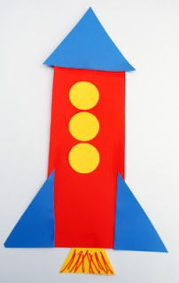
Please put finished entries into the envelope.
Good luck!
Ks2 Maths Space Challenge
Design your own Mathematical Space Rocket.
You must try and use:
- A range of quadrilaterals
- Different types of triangles
- Circles
- Polygons with more than 5 sides.

Once you have drawn your rocket label the different shapes you have used.

Please put finished entries into the envelope below.

Good luck!

